NS Norfolk Base history- information provided during a Bus Tour by Naval Station Tours – A 1-hour narration by a retired US Navy Captain, who asked everyone before moving… The Navy has had Steam driven propulsion since the 1860’s and we still have steam driven propulsion, so what has changed since then?
The Commissary and Exchange complex just outside the Base is the largest in the world. Notice all the above ground steam pipes used to heat many of the buildings. The heating steam lines at Naval Station Norfolk were part of the original power plant. This system has been in place since the early 1900s.
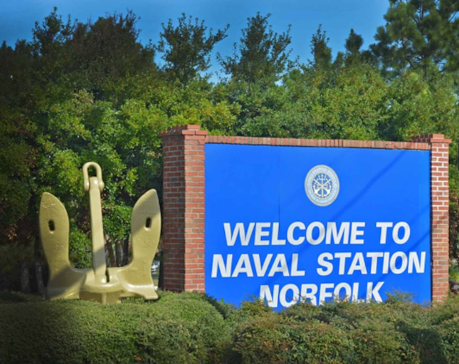
Going through Gate2 – Hampton Boulevard – Welcome to Naval Station Norfolk

Image from Naval Station Norfolk website

Historic homes still stand on Naval Station Norfolk now along Admiral’s Row.
Naval Station Norfolk dominates the waters of Hampton Roads. Ten years before the Navy began work on the vast Naval complex, much of the land on which it sits was devoted to a memorable and ambitious event — the Jamestown Exposition (Fair) of 1907.
In 1901, the General Assembly of Virginia passed a law authorizing the Governor to proclaim that the 300th anniversary of the landing at Jamestown in 1607 would be celebrated in 1907. The bill also invited cities and sections of Virginia to show how they proposed to commemorate the Tercentennial.
Norfolk’s citizens prevailed upon the City Council to appoint a committee to secure the event for the City. Eventually an expanded committee lobbied all Hampton Roads cities to support Norfolk as the site for the celebration. The committee successfully argued that Norfolk, due to its central location, was the logical choice for the Tercentennial celebration.
The General Assembly then passed a bill granting a charter to the Jamestown Exposition Company, which was to hold its celebration in 1907 at a site adjacent to Hampton Roads. The Company chose an agricultural area known as Sewells Point for the Exposition. It was equidistant from the Tidewater cities of Norfolk, Portsmouth, Newport News and Hampton.
The Jamestown Exposition Company sent invitations to all U.S. States requesting participation. Twenty-one states eventually erected buildings and exhibit pavillions that showcased the heritage of their state. The Exposition Company had agreed on a colonial theme and the buildings were often modeled after famous colonial structures from the home states.
State Commissioners were appointed to supervise the construction of the pavilions. They came to Norfolk to select sites for the buildings, lay the cornerstones and receive the keys to the completed structures from the contractors.
After the Exposition opened, participating states were further honored with special days, highlighted by elaborate social functions, often involving the respective governor.
The Exposition closed in November of 1907. While some of the state pavilions were purchased by the Fidelity Land and Investment Corporation, who purchased the Exposition site for $235,000, other states sold their houses to individuals.
Many Norfolk citizens had long thought of Sewells Point as an ideal place for a U.S. Navy base. A bill authorizing purchase of the site died in Congress in 1908, pushed aside in favor of a new coal ship, which the assistant secretary of the Navy deemed an absolute necessity.
Nothing was done until World War 1 erupted. When the U.S. entered the war in April 1917, Congress appropriated funds to purchase land at Sewells Point.
On June 28, 1917, President Woodrow Wilson issued a proclamation setting aside $1,200,000 as payment for the property, with an additional $1,600,000 for development of a Naval base. The land purchased comprised 474 acres, 367 of which were the old Jamestown Exposition grounds including several buildings.
On October 12, 1917, the Naval Training Station was officially established and thousands of young sailors flooded the new barracks.
The Navy continued to use a few of the Exposition buildings. Most state pavilions became housing for Naval officers, with Pennsylvania House eventually becoming an officers’ club. In 1932, the state buildings at the eastern end of the old Exposition grounds were moved west from Old Chambers Field at the Naval Air Station. These buildings joined the other state pavilions on Dillingham Avenue to complete the street that became known as Admirals’ Row.

Connecticut House - Connecticut used the Benjamin Tallmadge House in Litchfield, built in 1775, as the model for its building. Tallmadge was chief of the Intelligence Service and played an important role in the American Revolution. He identified and had custody of Major John Andre, a famous British spy, until the latter’s execution. The original house and its Exposition counterpart had gambrel roofs featuring a captain’s walk. There were two lower wings with two story columns on either side. The upper and lower porches of the Connecticut Building were screened. Its large entrance hall was furnished in a 17th century style. The drawing room was furnished with 18th century pieces. The tea room and a dining room also contained antiques from Connecticut. The Connecticut House was situated in what was known as the New England section of the Exposition grounds. After the Exposition, it became a private residence. In 1932 it was moved to its present location on Dillingham Boulevard.
Delaware House - It has been said that the Delaware Building was the oddest structure on the Exposition grounds. The small house (a model of a colonial homestead) had a hip roof, a comfortable porch and a parquet gallery. At each end of the house were huge chimneys. The eastern end of the building contained the reception room that was two stories high. The western end had a second floor. The reception hall housed the bell usually displayed in the State House in Dover. It was rung to notify the people that the British had closed the port of Boston, and again to announce that Delaware had ratified the Constitution. This building was originally located on Old Chambers Field. At the time of the Navy’s evaluation the owner of the property had spent, according to the board, “an inordinate amount of money” on the reconstruction of the building that he never occupied after this work was done. In 1932 it was moved to its present location at the corner of Dillingham Boulevard and Bacon Street.
Pennsylvania House - The Pennsylvania Building was a two-thirds reproduction of Independence Hall in Philadelphia. The large clock in the tower could be heard, tolling the hour, from any part of the Exposition grounds. The furnishings were, in the main, Colonial. Portraits of men famous in the State’s history adorned the walls, which also contained pictures of all the signers of the Declaration of Independence. Because of its historical significance, the building was used as a convention headquarters by such societies as the Descendents of the Signers of the Declaration of Independence, the Daughters of the American Revolution, the Colonial Dames of America, and the Sons of the American Revolution. Pennsylvania sold the building for $2,000. The evaluation board estimated the replacement value of the building “considered as a mass of material” at $13,000, and the cost of renovating at $7,500. It was owned by a Norfolk realty concern. Pennsylvania House, as it is now called, once served as the Officers’ Club on the Naval Station, and as the first home for the Hampton Roads Naval Museum. The house now hosts senior military-sponsored functions.
Georgia House - The Georgia Building was erected with funds raised by popular subscription. Its model was the birthplace of Martha Bulloch, mother of Theodore Roosevelt. She was married in the original mansion in Roswell, Ga. Her brother, James Dunwoody Bulloch, was an officer in the U.S. Navy for 10 years. Joining the Confederate Navy, he supervised the building of the Alabama in Liverpool. Another brother Irvine was said to have fired its last gun. President Roosevelt made the dedicatory speech when the Georgia Building was opened. The cities of Atlanta, Savannah, Augusta, Columbus, Valdosta, Macon, Rome and Statesboro each furnished one of the twelve rooms in the building. During the operation, the governor of the state presented a silver service to the battleship Georgia, which was accepted by President Roosevelt on behalf of the ship. This house was owned and occupied by an individual prior to Navy acquisition and the property was reported to have been well maintained. Georgia House stands in its original location.
Michigan House - The fact that the Michigan Building was not completed until September of the year of the Exposition, was partially due to a delay in beginning construction and partially due to bad weather after construction had begun. When completed, the lower floor consisted solely of a huge reception hall, floored and wainscoted with unstained Virginia pine. The wainscoting extended nearly to the ceiling, separated from it by only a narrow strip of dark burlap. It had been agreed that the furniture factories of Grand Rapids would furnish the house. This was not done, since the building was not completed until so near the end of the Exposition. It was furnished simply. The Michigan Building was moved after it had been purchased from the State, so that when the Navy acquired the house it occupied a lot fronting on what was then Willoughby Boulevard (now Old Chambers Field), between the Connecticut and Rhode Island Buildings, and occupied by the owner as a residence. It was moved again in 1932 to its present site on Dillingham Boulevard.
Missouri House - It was generally conceded that the Missouri Building was one of the handsomest of the state structures. A two-story portico with impressive columns faced Hampton Roads. Under this portico, and above the main entrance, hung a small balcony. There were verandas extending from the portico on either side. A side porch overlooked the water from the east. Missouri was one of the few state buildings that included a kitchen and dining room. Much entertaining was done here by the State, including a luncheon for Mary Custis Lee, daughter of General Robert E. Lee, on Virginia Day. Governor Charles Evans Hughes of New York (later Chief Justice Hughes) was a guest at a breakfast party at the Missouri Building. Of course, on Missouri Day when its own Governor was present, a brilliant reception was given in his honor. The house was owned and occupied by R.S. Brooks prior to Navy purchase. Missouri House stands in its original location.
New Hampshire House - The home of John Langdon in Portsmouth, New Hampshire was reproduced by the State. Langdon, ardent Revolutionary War patriot, was a signer of the Constitution, and President of the first United States Senate. He was several times Governor of the State. His home, built in 1784, is still standing and is now the property of the Society for the Preservation of New England Antiquities. The original has corner posts in the shape of Corinthian pilasters, with curved balusters. The portico supports a railing with turned balusters. Above the portico a surface scroll curves on each side of a large center window. A captain’s walk sits atop the hip roof, at either end of which is a chimney. Immediately below it are three dormer windows. Woodbury Langdon, a New York descendent of John Langdon, was said to have provided the funds for furnishing the State building. The New Hampshire House was the first of the state buildings to be purchased by an individual for use as a residence. In 1932 it was moved from Old Chambers Field to its present location on Dillingham Boulevard.
North Carolina House - The North Carolina Building was constructed and finished with native yellow pine. According to one source, Mrs. George Vanderbilt of Biltmore furnished one of the rooms from the fabulous Vanderbilt estate near Asheville; a furniture company from Mebane, North Carolina furnished another. Almost a year elapsed after the State Legislature made the first appropriation before commissioners were appointed who selected a site for their State’s headquarters. Possibly this accounts for the fact that the North Carolina Building was at the eastern end of the grounds, surrounded by New England neighbors. The Navy acquired this building from Theodore J. Wool who was occupying it as a residence. This building was moved to its present site from Old Chambers Field in 1932. Soon after, a fire broke out in the attic. After the fire was extinguished an examination revealed that, beneath the curling and blistered layers of paint, the North Carolina pine was stout as ever. Although unrecognizable, the North Carolina Building was rebuilt and combined with the Rhode Island House to make the Naval Station Senior Bachelor Officers’ Quarters.
West Virginia House - West Virginia built a two and one-half story buff colored frame house with dormer windows. The portico was supported by four columns adorned with Doric capitals and cornices. There were first and second floor porches on three sides. The stained glass landing window bore the State seal. The entrance led through a vestibule into the reception hall, which was supported by Ionic pilasters. Above the pilasters were mahogany beams. A drawing room and general parlor led off from the reception hall, but sliding doors gave the effect of one huge room. The second floor, reached by a grand stairway, contained bedrooms for the State’s visiting dignitaries. After purchasing this building in 1917 for $14,700, the Navy used it as one living quarter. In 1942, when additional quarters were badly needed, a brick wall was run through the center of the house, which, with the addition of a kitchen wing, enlarged it to two quarters. Bedrooms were added over the kitchen wings, giving each quarters five bedrooms.
Other Exposition structures on the Naval Station include the Baker’s Chocolate Building and the Mothers’ and Children’s Building (now residences); the History Building (now a gymnasium); and two wings of the Auditorium (now Navy administrative buildings). The wings survived a 1941 fire that destroyed the main Auditorium building, which was replaced by the current Building N-26.
For more information on the Jamestown 1907 Exposition, please visit the Hampton Roads Naval Museum’s web site. Credit for this information goes to an article written as “Historic Homes still standing on Naval Station Norfolk” in The Flagship.
Next in the tour was seeing the “aircraft” side of NS Norfolk. (Naval Station Norfolk and Naval Air Station Norfolk were combined in February 1998, when NAS Norfolk was absorbed into Naval Station Norfolk.) Hangers with navy personnel working on the E-2D Advance Hawkeye due to the recent establishment of an Air Squadron assigned to the NS Norfolk air fields. We also saw an MH-60S Knighthawk take off, one of many lined up on the tarmac.
Home to Airborne Command & Control Squadron (VAW) 124. Located onboard Naval Station Norfolk in Virginia, the Bear Aces report operationally to Commander, Carrier Air Wing (CVW) 8 and administratively to Commander, Airborne Command & Control and Logistics Wing (ACCLW). In the summer of 2021, VAW-124 retired their E-2C Group II Hawkeyes and transitioned to flying the E-2D Advanced Hawkeye. At the same time CVW-8 was reassigned to USS Gerald R. Ford. The all-weather aircraft is equipped with the advanced APY-9 radar as well as a suite of other communications, data management, and information relay systems that allow its’ use to be effective battle managers. They act as the “Quarterbacks of the Sky” providing critical tactical command and control in support of Carrier Strike Group 12 in missions such as airborne early warning, air intercept control, surface surveillance coordination, strike coordination, and offensive air support. (From Naval Air Force Atlantic (Airlant) article).
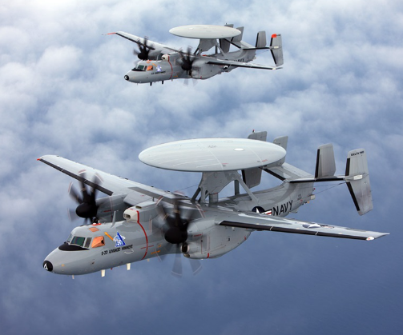

Image from northropgrumman website

Then a story about Captain Chambers (father of naval aeronautics- with no flying skills and Ugene Ely (a self taught aviator and first to land on a ship), there are a streets named after them on the Naval Station. (from Smithsonian and Wikipedia)
Irving Chambers was given the nickname "Skipper" by his father and graduated from the Naval Academy in 1915. He served 31 years in the Navy, attaining the rank of captain. Irving Chambers qualified as a submarine officer, and as a lieutenant in 1921 commanding the submarine USS R-6 (SS-83), he was the last man off the boat when it sank at San Pedro Bay (California) due to a malfunctioning torpedo tube door on September 26 that year. Captain Washington Irving Chambers, USN (April 4, 1856 – September 23, 1934) was a 43-year, career United States Navy officer, who near the end of his service played a major role in the early development of U.S.Naval aviation, serving as the first officer to have oversight of the Navy's incipient aviation program through the Bureau of Navigation. In that capacity from 1910 to 1913, he consulted and worked with early civil aviation pioneers Orville Wright and Glenn Curtiss; organized the first airplane landing (1911) and takeoff (1910) from a ship in collaboration with pioneer aviator Eugene Ely; recruited the first naval aviators; established aviator training; oversaw the first budget appropriation of $25,000 from which he purchased the first aircraft for the Navy; designed a catapult to launch aircraft from warships and led a Board that recommended establishment of the first naval air station at Pensacola, Florida and advocated for the establishment of a "national aerodynamic laboratory". Chambers has been called "the Father of Naval Aviation".
After receiving an engineering degree in 1904 from Iowa State University, Ely began a career in the fledging automobile industry as a salesman, mechanic, and racing driver. He taught himself to fly in 1910 and never looked back. He had natural skills as an aviator and quickly became a well-known pilot with the Curtiss Exhibition Team that toured all around the county. In the fall of 1910, the Navy identified Captain Washington I. Chambers “to observe everything that will be of use in the study of aviation and its influence upon the problems of naval warfare.” Chambers quickly realized the most important first step to prove that the airplane could operate at sea was to show that landings and take-offs from ships were possible. Chambers attended one of the first major flying meetings, being held at Belmont Park, NY, in October 1910. He met Glenn Curtiss and Eugene Ely at the competition and made a proposition. If he would supply the ship, would they make the attempt to land on board? Ely was excited at the prospect and agreed.
On November 14, 1910, the light cruiser USS Birmingham was readied at Norfolk, Va., with a wooden platform erected on the bow, approximately 80 feet long. Ely’s Curtiss Pusher aircraft (similar to the Curtiss D-III Headless Pusher on display at the National Mall Building), equipped with floats under the wings, was hoisted aboard and the ship moved off shore. Ely succeeded in making the first take-off from a ship, barely. The Curtiss rolled off the edge of the platform, settled, and briefly skipped off the water, damaging the propeller. Ely managed to stay airborne and landed 2 ½ miles away on the nearest land, called Willoughby Spit.
Taking off a ship was one thing. Landing on one was quite another. Despite the somewhat harrowing flight off the Birmingham, Ely was ready to try. With Ely and the Curtiss team scheduled to fly in San Francisco in January, Chambers made arrangements for the attempt on the west coast. The armored cruiser USS Pennsylvania was prepared and anchored in San Francisco Bay. This time a longer platform was in place, 120 feet, along with ropes and sandbags stretched across to serve as a crude arresting system for landing. There was also a canvas awning at the end to catch the airplane if the ropes and sandbags were not sufficient. With longer wings and hooks on the landing gear, and Ely donning a padded football helmet and bicycle inner tubes around his body in case anything went awry, all was ready on the morning of January 18, 1911. Crowds lined the shore and boats collected in the harbor to witness the daring flight. At 11:00 a.m., Ely took off from nearby Tanforan Race Track and headed for the Pennsylvania. To the delight of thousands of spectators, Ely made a safe landing, the arresting equipment working perfectly. After lunch with the ship’s captain and a few photographs, the platform was cleared and the Pennsylvania was pointed into the wind. Ely took off, flew past the crowd, and landed safely back at Tanforan. Naval aviation was born.
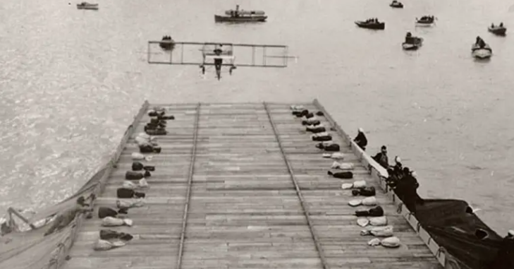
Picture from National Air and Space Museum

U.S. Naval Aviation was born 8 May 1911, with a purchase request made by Captain Washington Irving Chambers for the Navy's first aircraft. In the years leading up to World War I, pioneer aviators pushed the development of hydroaeroplanes and flying boats, turning them into effective tools for warfare and working to integrate Naval Aviation into the Navy's mission to protect and control the seas.
In 1909, military aviation began with the purchase of the Wright Military Flyer by the U.S. Army. The Navy sprouted wings two years later in 1911 with a number of significant firsts. The first U.S Navy officers were trained to fly, the Navy purchased its first airplanes from Glenn Curtiss and the Wrights, and sites for naval aircraft operations were established at Annapolis, Md., and at North Island, San Diego, Ca. But the most dramatic demonstration that the skies and the seas were now joined occurred on January 18, 1911, when Eugene Burton Ely made the first successful landing and take-off from a naval vessel.

Next was the description and use of each plane and helocopter on display just inside Gate 4 – The Naval Air Station Norfolk Memorial Park.(from silverhawkauthor) and Hornet diplay nearby.
The dedication of the F/A-18 Hornet
Boeing Vertol HH-46D Sea Knight,
Grumman A-6E Intruder,
Grumman E-2B Hawkeye,
Grumman F-14A Tomcat,
Kaman SH-2F Sea Sprite,
Sikorsky RH-53D Sea Stallion, and
Sikorsky SH-3H Sea King.

We then heard the story of the ironship battle taking place just off shore while overlooking Chesapeake Bay.
The first battle between ironclad ships occurred on March 8th&9th, 1862, during the American Civil War. , When they met near the mouth of the Chesapeake Bay, Union iron-plated gunboats had already been plying the waters of Western Theater rivers for some weeks. But no two such ships had ever faced each other in combat. So, as the Virginia approached the Minnesota (wooden), it noticed a strange raft-like vessel defending its quarry and shifted fire to the newcomer, USS Monitor. The two vessels each featured innovative design characteristics. Virginia, (built on the hull of the USS Merrimack, which had been burned and scuttled when the Union navy abandoned the Norfolk Navy Yard in April 1861), was larger and mounted a total of 10 stationary guns, plus a 1,500-pound iron ram on its bow. Nearly 100 feet shorter and with only a quarter of the displacement, Monitor was more maneuverable, an attribute augmented by the flexibility of the two guns in her rotating turret. The two ironclads then settled down to a close range slug-fest, both landing hits that took little effect. After several hours of close combat, Monitor disengaged and headed for the safety of shallower waters, its commander temporarily blinded by a shell that exploded near the viewing slit of the pilothouse. Virginia, short on ammunition and conscious of the retreating tide, retired to Norfolk. The first battle between steam-powered, ironclad warships had ended in a draw. This battle marked a significant turning point in naval warfare, demonstrating the effectiveness of armored ships over traditional wooden vessels. (All the world’s wooden battleships were then obsolete!)
Then there was the USS Iowa memorial –
The USS Iowa was participating in firing exercises during maneuvers with the US Second Fleet, about 300 miles northeast of Puerto Rico. A 3-gun salvo was ordered for Turret Two. Turret Two's right and left guns were load and ready. It was reported over the turret's phone circuit that the center gun was having problems, they weren't ready yet. At 9:53am, the center gun in Turret Two exploded, killing all 47 crew members and severely damaging the gun turret. It buckled the bulkheads separating the center gun room from the left and right gun rooms. A fireball spread throughout the gunrooms and the lower levels of the turret. Burning polyurethane foam released cyanide gas, and other toxic gases filled the turret. The heat and fire ignited 2,000 pounds of powder in the powder-handling area of the turret. A second explosion occurred approximately 9 minutes after the initial explosion, most likely due to a build up of carbon monoxide gas. Twelve men in the bottom of the turret were able to escape without serious injury. The automatic sprinkler system in Turret Two failed to operate. Firefighting crews sprayed the roof of the turret and the still loaded right and left guns with water. An inspection of the powder flats in the turret determined that several tons of unexploded powder bags were "glowing" and the turret was flooded with seawater to prevent the powder from exploding. The Iowa returned to Norfolk, VA on April 23. On April 24th, a memorial service was held, attended by family members and several thousand people. President George H. W. Bush, and his wife, Barbara, were among the dignitaries present. President Bush spoke and afterwards met with the family members of the fallen crewmen. An independent review and investigation by Sandia National Laboratories determined there was an overram of the powder bags as they were being loaded and the overram may have caused the explosion. The bronze plaque has a rendering of the USS Iowa and lists all 47 names of the fallen crewmen. The plaque is set in marble and is on a stone pedestal base. It is at Iowa Point on the Norfolk Naval Base, and overlooks the Chesapeake Bay.

We then stopped at the USS Cole memorial.
In August of 2000, USS Cole (DDG 67) sailed from Naval Station Norfolk, Virginia, to the Gulf of Aden, Yemen. On October 12, while refueling at port in Aden, two al-Qaeda terrorists in a speedboat detonated a bomb along the port side of Cole. The explosion tore a 40 by 60 foot wide hole into the side of Cole, killing 17 Sailors and wounding an additional 37 shipmates.
The USS Cole was transported to the Pascagoula shipyard from Yemen aboard the Norwegian heavy-lift ship MV Blue Marlin after it was damaged in a terrorist attack. The ship arrived in Pascagoula on December 13, 2000, for extensive repairs.
On October 12, 2001, one year after the attack, the USS Cole Memorial was dedicated at Naval Station Norfolk, the Navy base in Virginia, to honor the memory of the victims.
The two outer brass plaques on the granite bands list the names, ages, ranks, and hometowns of the USS Cole Sailors who were killed. The center plaque memorializes the crew's sacrifice and service, and the 17 granite slabs around the monolith represent each Sailor. The ship returned to her homeport of Naval Station Norfolk, Virginia, and resumed active duty in 2002. AND was available to see during the tour of the ships docked!

Then we cruised along the peers not only seeing the USS Cole DDG-67, but also an Aircraft Carrier (USS Truman CVN-75), Battleships (as the USS New Jersey BB-62), another Arleigh Burke-class guided missile destroyer (one was on it’s way in with tugboat guidance), an amphibious assault ship, a few more tugboats, a resupply ship (the USNS Robert F. Kennedy (T-AO 8) with Civil Service Mariners(CIVMARS)), a couple of submarines, and further down we could just make out a US Navy Mercy-class hospital ship (USNS Comfort).

Great Tour!

